**Assignment Day 4 | 23rd August 2020**

**By Sameer Kulkarni**

**Question 1:** Find out the mail servers of the following domain:

Ibm.com

Wipro.com

**Answer 1:** The mail servers of domains can be found with following Commands

nslookup

|  |  |
| --- | --- |
|  | The mail server of Ibm.com is hostmaster.akamai.com |
|  | The mail server of wipro.com is  awsdns-hostmaster.amazon.com |

**Question 2:** Find the locations, where these email servers are hosted.

**Answer 2:**

|  |  |
| --- | --- |
|  | I had a mail from IBM Watson. The email header was used in emailtrackerpro. The mail server of ibm.com is located in France. |
|  | The email header was used in emailtrackerpro. The mail server of wipro.com is located in Bangalore, India. |

**Question 3:** Scan and find out port numbers open 203.163.246.23

**Answer 3:** The ports open for any system can be found out with nmap.

|  |  |
| --- | --- |
|  | The open ports found with the nmap command are as follows:  Nil Open Ports. All are filtered. |

**Question 4:** Install nessus in a VM and scan your laptop/desktop for CVE.

**Answer 4:** Nessus was installed in VM and my laptop was scanned for CVE. The screenshots are as follows:

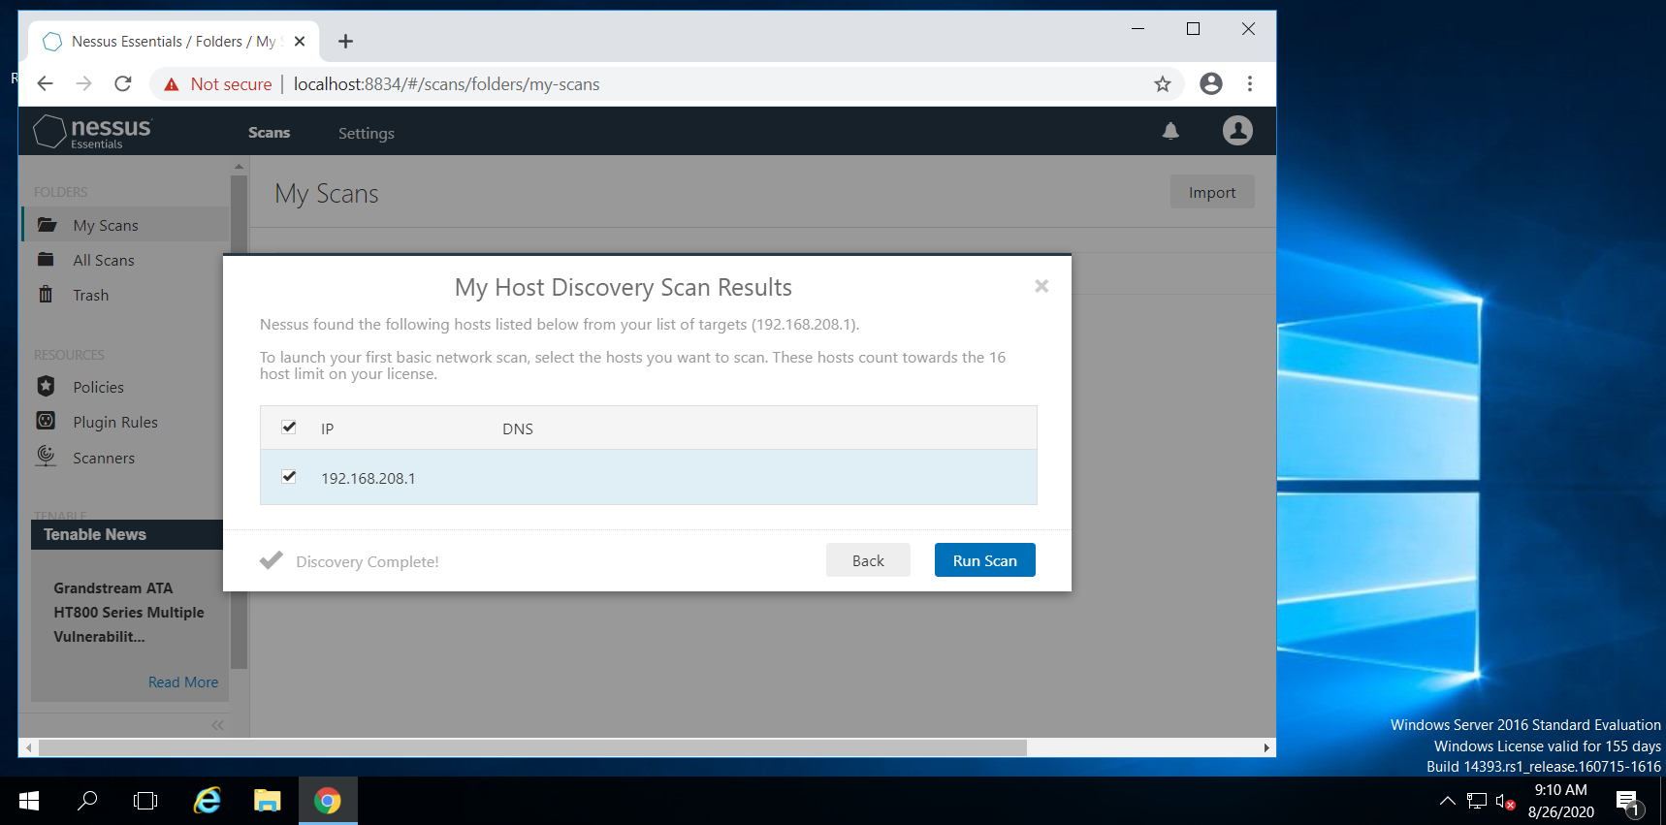

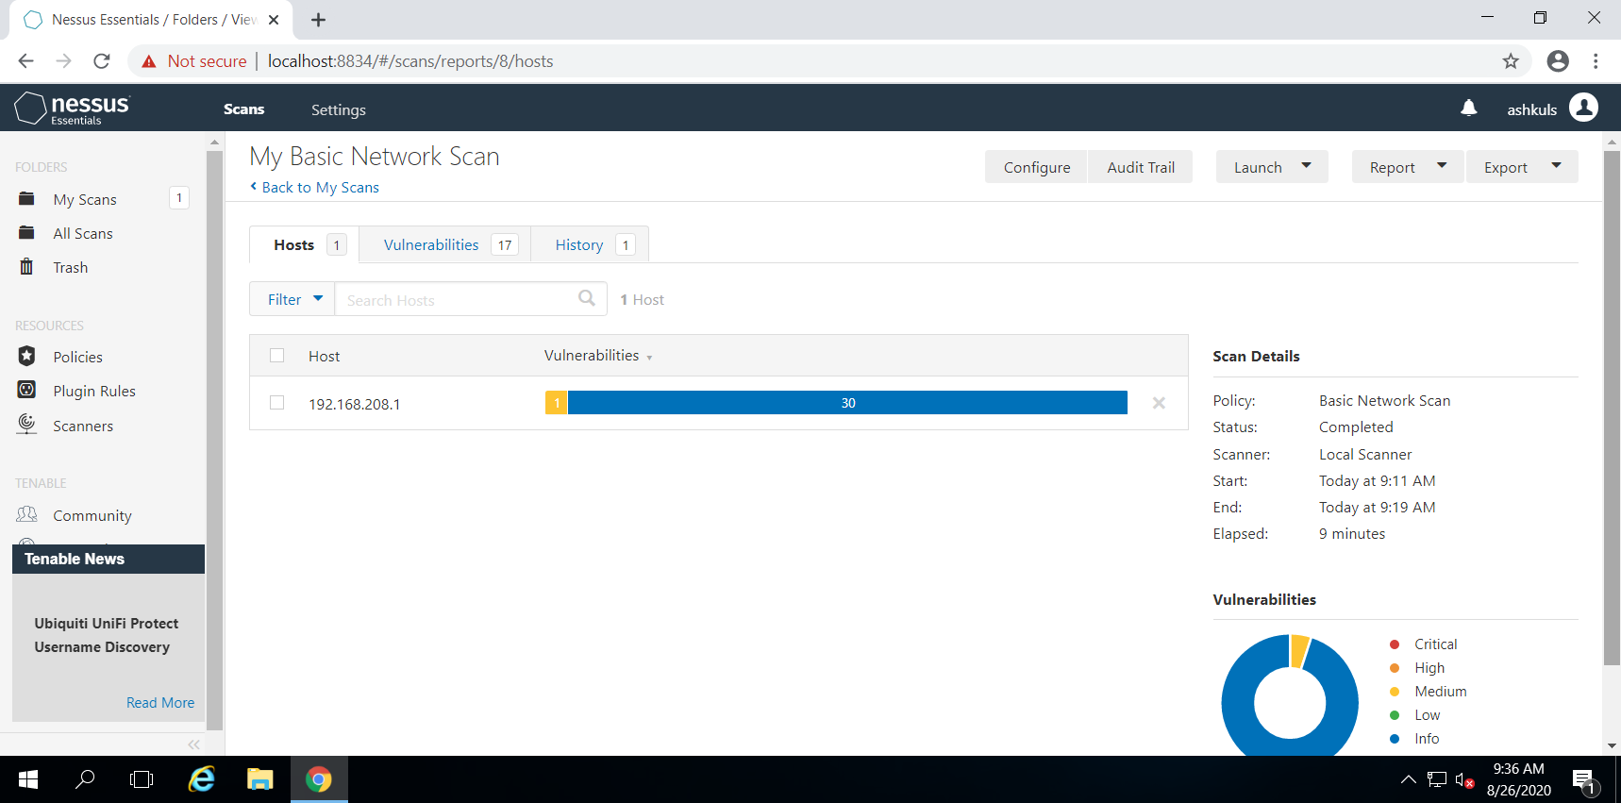

There was only one Medium vulnerability about SMB Signing not required, which is irrelevant for my Windows 10 Home edition without domain and hence was not resolved.